This is an analysis of the cars dataset that is distributed with R.

Here is a table showing the first 10 observations:

|  |  |  |
| --- | --- | --- |
|  |  |  |
|  |  |  |
|  |  |  |
|  |  |  |
|  |  |  |
|  |  |  |
|  |  |  |
|  |  |  |
|  |  |  |
|  |  |  |
|  |  |  |

There are n= observations in this dataset, and the mean speed is .

The relationship between speed and distance looks like:

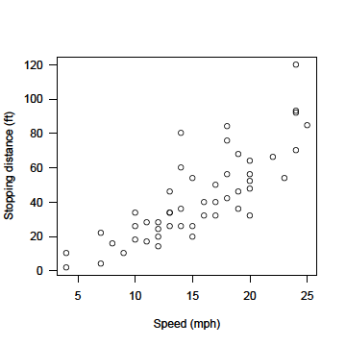

In a univariate model, speed and distance are related as follows:

Call:

lm(formula = dist ~ speed, data = cars)

Residuals:

Min 1Q Median 3Q Max

-29.069 -9.525 -2.272 9.215 43.201

Coefficients:

Estimate Std. Error t value Pr(>|t|)

(Intercept) -17.5791 6.7584 -2.601 0.0123 *

speed 3.9324 0.4155 9.464 1.49e-12 ***

---

Signif. codes: 0 '***' 0.001 '**' 0.01 '*' 0.05 '.' 0.1 ' ' 1

Residual standard error: 15.38 on 48 degrees of freedom

Multiple R-squared: 0.6511, Adjusted R-squared: 0.6438

F-statistic: 89.57 on 1 and 48 DF, p-value: 1.49e-12